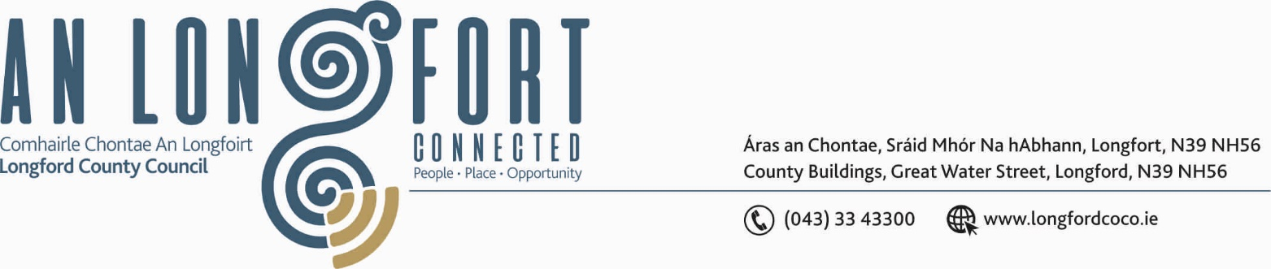

LONGFORD MUNICIPAL DISTRICT

26th April 2018.

To: Each Member of Longford Municipal District.

Dear Member,

You are requested to attend Meeting of Longford Municipal District to be held in the Council Chamber, Town Hall, Market Square, Longford, on Wednesday,
2nd May 2018 at 4.00 p.m. to transact business, as set out on the Agenda hereunder.

Yours sincerely,
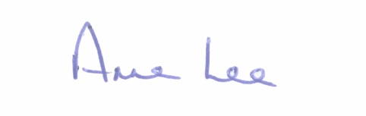

_______________
Anne Lee,
Meetings Administrator.

AGENDA

Prayer before meeting.

1. Confirmation of Minutes of the following meetings of Longford Municipal District–
(i) Committee Meeting held on the 28th March 2018.
- Monthly Meeting held on the 28th March 2018.

2. Matters arising from Minutes.

3. Management Report - to follow.

4. Attendance of Ray Murphy, Co-ordinator of Ardnacassa Regeneration Plan.

5. Consideration of recommendations from the Placenames Sub-Committee regarding the naming of the following -

- New Bridge over the Camlin River.
- Link Road between N63 and N5

6. Retail Regeneration – Link attached.
https://www.theguardian.com/lifeandstyle/2018/mar/29/high-street-closed-betting-shops-york-back-from-dead

7. Update on extension to Ballymacormack Cemetery.

8. Notices of Motions submitted by Councillors, as listed hereunder –

Councillor Gerry Warnock.

“ I am proposing that Longford County Council initiate the procurement process to bring the dozen or so council owned properties within the Greater Ardnacassa area back into stock. I am further proposing that these properties are allocated under a Choice Based Letting Initiative which should be prepped during procurement/construction and ready to roll out as expediently as possible following completion of works. To incentivise participation in the CBL Scheme I am proposing that a nominal rent be applied to these properties for the first twelve months of letting. It is my belief that by populating these voids in one swoop with suitable households, we will greatly contribute to the overall regeneration of the Ardnacassa area and enhance the efforts already being rolled out by this local authority in our goal to create a safer environment for the decent people who already reside there.”

Councillor Joe Flaherty.

“Calling on the Municipal District to look at the urgent provision of a pedestrian crossing for Park Road under the terms of Low Cost Safety measure. Failing that, to look to finance this much needed crossing through the Towns & Villages Scheme funding.”

Councillor Mae Sexton.

“That Longford Municipal District applies for a Low Cost Safety Scheme at Stonepark, as a matter of urgency.”

“That lighting and footpath/safe walking area be provided for Glebe/Lisduff Hill.”

9. Correspondence - enclosed.

- Letter dated 20th April 2018 received from An Garda Siochana regarding reporting of incidents in the Ardnacassa/Cluain Ard area.

